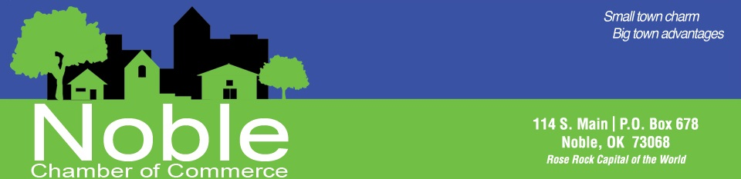
Exciting opportunities to sponsor events hosted by the
Noble Chamber of Commerce
We understand that as a business it may be easier to choose options from one event or many and just write one check that fits in your budget. We have put together this list for you to review and choose what works best for you!

Annual Banquet- January
Individual Ticket $60
- One individual ticket for dinner and event

Silver Level $50-$100
- Company Name on Schedule of Events-$50
- Company Name and Phone number on Schedule of Events-$75
- Company Logo, Name and phone number on Schedule of Events- $100

Gold Level $300
- Table seating for 4 with Signage
- Announcement of Sponsorship on email & FaceBook
- Company Name on Schedule of Events

Diamond Level $500
All Gold Level benefits PLUS:
- Additional seating for 4 with Signage
- Logo on Event slideshow
- Company Phone number on Schedule of Events

Entertainment Sponsor $1000
All Diamond Level benefits PLUS:
- Sign on stage

Platinum Level $1500
All Diamond Level benefits PLUS:
- Prominent center table for your 8 seats with Signage
- Company Logo on Photo Back Drop
- CEO/Company Representative recognized from podium
City Wide Garage Sale- last Saturday in April
Advertising Sponsor $100
- Name on Garage Sale Maps/List
- Name Advertised on Social Media & Website with Garage Sale event information

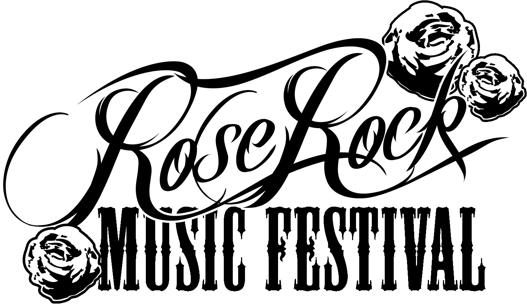 - May 1st-3rd

Basic Level $100

Business name recognition in sponsor promotions on website and in social media

Bronze Level $250
All Basic Level benefits PLUS:
- Business name recognition on Event Sponsor Sign displayed at the Festival
- Business name only printed on all Rose Rock Posters and Schedule of Events
- Business name only printed on the official Rose Rock Music Festival T-shirt
- Carnival tickets- 3 strips total. Each strip has 5 tickets.

Parade Sponsor $350
All Bronze Level benefits PLUS:
- Recognized and Announced as Parade Sponsor.
- Present Parade Winners with Awards on stage at the Festival
- Carnival tickets- 4 strips total. Each strip has 5 tickets.

Cornhole King (1 available) $500
All Bronze Level benefits Plus:
- Sponsor Remarks at the start of the tournament
- Your banner hung at the Cornhole Tournament
- 1 Cornhole Team of two players at the tournament
- Large Company Logo listed on Facebook event, website and printed media

Silver Level $500
All Bronze Level benefits PLUS:
- Upgrade to Small Business Logo printed on Rose Rock Posters, Schedule of Events & Festival
T-shirt
- Complimentary Booth Space at the Festival
- More Carnival tickets- 6 strips total. Each strip has 5 tickets.

Wrestling &/or Entertainment Sponsor $1000 each
All Silver Level benefits PLUS:
- Upgrade to Medium Business Logo printed on Rose Rock Posters, Schedule of Events and Festival T-shirt
- Signs &/or Banners around stage area
- Commercial spot to be played in between musical performances over the PA during the festival
- More Carnival tickets- 7 strips total. Each strip has 5 tickets.

Gold Level $1500
All of the Silver Level benefits PLUS:
- Commercial spot to be played in between musical performances over the PA during the festival
- Upgrade to Medium Logo printed on Rose Rock Posters, Schedule of Events and Festival T-shirt
- Even More Carnival tickets- 9 strips total. Each strip has 5 tickets.

Platinum Level $2500
All of the Gold Level benefits PLUS:
- Upgrade to Largest business logo on Schedule of Events, T-shirts, and Posters.
- Promoted as Platinum Sponsor on Main Event sign and all advertising.
- Large Banner with Logo & Business Name on Stage area
- Most Carnival tickets- 18 strips total. Each strip has 5 tickets.

City Wide Garage Sale- last Saturday in July
Advertising Sponsor $100
- Name on Garage Sale Maps/List
- Name Advertised on Social Media & Website with Garage Sale event information

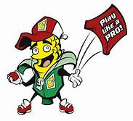Cornhole Cornament- October 24th

Dirty Bag (3 available) $50
Business Logo and Information signs posted at Bathroom Sights

Cornholer (19 available) $100
Company Log On bottom of Cornhole Board

Slick Woody (8 available) $150
- 2 meal tickets
- 1 Cornhole Team of two players in the tournament
- Company listed on Facebook event, website and printed media

Cornizzle (1 available) $200
Exclusive marketing of registration area
- Your Business Banner hung at registration area
- Opportunity to staff registration table with your business employees in company shirts
- 1 Cornhole Team of two players in the tournament
- Small Company listed Logo on Facebook event, website and printed media

Cornstar (1 available) $200
Exclusive marketing at the Cornhole Tournament Bracket Area
- Your banner hung at the Bracket Area
- 1 Cornhole Team of two players at the tournament
- 1 Booth space at the Fall Festival
- Small Company Logo listed on Facebook event, website and printed media

The Husker (4 available) $200
Verbal recognition during the tournament
- 1 Cornhole Team of two players at the tournament
- 1 Booth space at the Fall Festival
- Small Company listed on Facebook event, website and printed media

Cornhole King (1 available) $300
Sponsor Remarks at the start of the tournament
- 1 Board Sponsor (additional $50)
- Your banner hung at the Music Area
- 1 Cornhole Team of two players at the tournament
- 1 Booth space at the Fall Festival
- Large Company Logo listed on Facebook event, website and printed media

It’s Fall Y’all-October 24th
Doggie Costume Contest Sponsor $50
- Name on Award
- Name on all event posters & flyers

Fall Baking Contest Sponsor $50
- Name on Rolling Pin Award
- Name on all event posters & flyers

Pumpkin Carving/Decorating Contest Sponsor $50
- Name on all event posters & flyers
- Name on award

Scarecrow Stroll Sponsor $50
- Name on all event posters & flyers
- Name on award

Haunting Main Street- October 29th 4-6 pm
Spooky Sponsor $250
- Prime location to pass out candy downtown Main Street at 114 S Main with advertisement of your business
- Name on event posters & flyers
- Name on Social Media & Website

Christmas in Noble- December 5
Jingle Bell Rock $2500
- Announcement at Downtown Lighting
- Sign at the Tree
- Company Logo Snap Chat Filter
- Name on event T-shirt, flyers & posters
- Name on social media & website
- Recognition In Thank You Advertising
- Commemorative 2019 Christmas in Noble Ornament
- One Tree Topper Sponsorship
- Booth at the Holiday Market

Holly Jolly Christmas (Entertainment Sponsor) $1500
- Announcement at the Tower Lighting
- Banner at the Stage
- Name on event t-shirt, flyers & posters
- Company Logo Snap Chat Filter
- Name on social media & website
- Recognition in Thank You Advertising
- Commemorative 2019 Christmas in Noble Ornament
- Booth at the Holiday Market

Rockin’ Around the Christmas Tree $1000
- Stand with Santa to Flip the Switch
- Sign at the Tree
- Company Logo on Snap Chat Filter
- Name on event t-shirt, flyers & posters
- Name on social media & website
- Recognition in Thank You Advertising
- Commemorative 2019 Christmas in Noble Ornament
- Booth at the Holiday Market

Sleigh Bells Ring $750
- Sign at the Santa’s Sleigh
- Company Logo Snap Chat Filter
- Name on event t-shirt, flyers & posters
- Name on social media & website
- Recognition in Thank You Advertising
- Commemorative 2019 Christmas in Noble Ornament
- Booth at the Holiday Market
Christmas Parade Sponsor..............................................................................................$500
- Parade Marshall
- Banner on parade vehicle
- Name on event t-shirt, flyers & posters
- Name on social media & website
- Name on award
- Christmas Tree Sign with name on it Downtown

Christmas Cookie Baking Contest……………………………………………………..………………………………$50
- Name on event flyers & posters
- Name on social media & website
- Name on Award
- Christmas Tree sign with Name on it Downtown

Christmas Ornament Scavenger Hunt……………………………………………………………………………..$50
- Name on event flyers & posters
- Name on social media & website
- Name on Award
- Ornament Sign with Name on it Downtown

Elf on a Shelf Scavenger Hunt………………………………………………………………… $ Purchase of Prizes
- Name on event flyers & posters
- Name on social media & website
- Christmas Tree Sign with name on it Downtown

Gingerbread House Contest ……………………………………………………………………………………………..$50
- Name on event flyers & posters
- Name on social media & website
- Name on Awards
- Gingerbread House Sign with name on it Downtown

Gingerbread Village Sponsor (8)……………………………………………………………………………………..$100
- Name on Santa’s Good List
- Name on event t-shirt, flyers & posters
- Name on social media & website
Holiday Market Sponsor ……………………………………………………………………………………………..$100
- Name on Christmas Sign
- Name on event t-shirt, flyers & posters
- Name on social media & website
- Christmas Tree Sign with name on it Downtown

Hot Chocolate Crawl Sponsor (unlimited) $ Purchase of Hot Chocolate & Supplies
- Name on event flyers & posters
- Name on social media & website
- Name on hot chocolate table at event

Hot Chocolate Entertainment Sponsor provide hot chocolate and supplies for the event
- Name on event flyers & posters
- Name on social media & website
- Name on hot chocolate table at event

Jolly Old St. Nicholas Sponsor (pictures with santa) $100
- Name on event flyers & posters
- Name on social media & website
- Sign with Company Name in the Santa Picture Area

Letters to Santa $ Purchase of Santa Stationary & envelopes
- Name on event flyers & posters
- Name on social media & website
- Christmas Tree Sign with name on it Downtown
- Provide Location

Lighting and Decorating Contest (3 sponsors)…………….…………………………………………………….$50
- Name on event flyers & posters
- Name on social media & website
- Name on Awards
- Christmas Tree Sign with name on it Downtown

Mrs. Claus’ Kitchen Cookie Sponsorship……………………………………provide cookies for the event
- Name on event flyers & posters
- Name on social media & website
- Name on cookie table at event
- Christmas Tree Sign with name on it Downtown

Parade Character Meet and Greet……………………………………….…………………………………………..$50
- Name on event flyers & posters
- Name on social media & website
- Christmas Tree sign with name on it Downtown

Reindeer Games Sponsor(children’s game area)…………………………………………………………… $100
- Name on event t-shirt, flyers & posters
- Name on social media & website
- Christmas Tree Sign with Name on it Downtown

Santa’s Workshop Sponsor (children’s ornament gift)… $250
- Name on event t-shirt, flyers & posters
- Name on social media & website
- Christmas Tree Sign with Company Name in craft area

Tree Topper (12 Available)………………………………………………………………………………………….$100
- Company Name on Tree Topper
- Name on event t-shirt, flyers & posters
- Name on social media & website

Ugly Sweater Contest……………………………………………………………………………………………………….$50
- Name on event flyers & posters
- Name on social media & website
- Name on Awards
- Christmas Tree Sign with Company name on it Downtown

Wreath Decorating Contest…………………………………………………………...……………………………….$50
- Name on event flyers & posters
- Name on social media & website
- Name on Awards
- Ornament Sign Downtown with Name on it

Christmas Cornhole Cornament- December 5
Cornholer (19 available) $100
Company Logo on Cornhole Score Board

Slick Woody (8 available) $150
- 2 meal tickets
- 1 Cornhole Team of two players in the tournament
- Company listed on Facebook event, website and printed media

Cornizzle $200
Exclusive marketing of registration area
- Your Business Banner hung at registration area
- Opportunity to staff registration table with your business employees in company shirts
- 1 Cornhole Team of two players in the tournament
- Small Company listed Logo on Facebook event, website and printed media

Cornhole King $300
Sponsor Remarks at the start of the tournament
- 1 Board Sponsor (additional $50)
- Your banner hung at the Music Area
- 1 Cornhole Team of two players at the tournament
- 1 Booth space at the Holiday Market
- Large Company Logo listed on Facebook event, website and printed media

