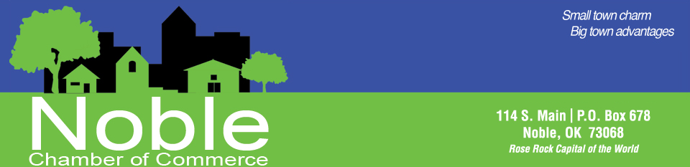
Descriptions of Membership Benefits
Opportunities to Host Networking Events
As a Noble Chamber Member, you can host the monthly Community Coffee, a Business After Hours, Ribbon Cutting or Open House.
Networking Opportunities
Networking is one of the main reasons businesses join a chamber. The Noble Chamber provides dozens of effective networking opportunities to our members. Taking advantage of these events enables business owners to know all the movers and shakers in our community. More importantly, they will know you and your business. The Noble Chamber wants to equip our member businesses with the tools and information needed to become highly successful. It is critical we, as business owners, stay informed about issues affecting our bottom line and technology which can enhance our visibility, marketing and leadership skills. Networking opportunities include Community Coffee, Business After Hours, Business Owner’s Round Table, Member Lunch, Open Houses, and the Annual Chamber Banquet.
- Community Coffee events are held the second Friday of every month from 8 to 9 a.m. Chamber Members invite the community into their businesses for a cup of coffee. This informal get together provides an opportunity for people to walk into your business, sometimes for the first time. Everyone has the opportunity to make announcements about their businesses as well as about events in and around Noble. We call it the “walking bulletin board.” Many members have made valuable business connections through this unique networking event.
- Ribbon Cuttings let us help you advertise your new business. We can help you stage a ribbon cutting or open house to promote your business and attract a crowd. New businesses that are just opening their doors want the community to become acquainted with the services offered as soon as possible. A ribbon cutting ceremony provides photo ops and news coverage.
- Business After Hours events provide a casual setting in which to meet other business owners and community members for a relaxing visit. You won’t want to miss these ever-popular opportunities to promote your business and tell your story in a one-on-one environment. This is held upon request by a Chamber member.

Business Referrals

Chamber member businesses are given priority when inquiries for products or services are received in the Chamber Office.

Membership Lunch Business Spotlight & Education Trainings
These are held the third Wednesday of every month for one hour. It is an opportunity for a Chamber member to make a presentation about his or her company, services and products. This powerful tool gives you an edge the next time someone needs services your company provides. During our monthly Membership Luncheon, 25 minutes is devoted to an educational segment to equip our members with the latest info on a variety of topics.

Legislative Updates
Weekly legislative updates sent via email to all members to keep you apprised of the actions at the Capitol.
Email Promotions
Promotion of all members business events and specials through our extensive E-mail list & on our website.
High Visibility in Community Events
The Noble Chamber sponsors or partners with others in putting on a large number of Community Events. Every event gives you, as a Chamber member, a special method of showcasing your business.
- Rose Rock Music Festival: Held the first weekend in May every year, this Festival has expanded to three days. There are so many ways to showcase your business through this event. Sponsorships, booth space and the parade are great ways to be visible. The Chamber members work together for months to make this event a great success every year. You will want to be a part of this fun and popular Festival.
- Disc Golf Tournament: Our first Disc Golf Tournament was held in 2015 with great success. The second one in 2016 we were able to procure many more prizes for the players & items for player packs. This new event has been enjoyed by many community members. We look forward to this annual event.
- Haunting Main Street: Hundreds of ghosts and goblins haunt Main Street every year around Halloween. Community & Chamber members set up tables along Main Street and hand out candy. We help businesses not located on Main Street find a visible place to hand out candy and join in the fun. Dressing up and seeing if your customers recognize you is always fun.
- Fall Festival: This event brings many vendors to our main street corridor with booths, hay rides, kid zone and more. This allows visitors to check out our main street which promotes our local businesses.
- Christmas In Noble: Is a community wide event. It is a great way to promote your business by participating in the day’s events like the hot chocolate crawl, lighted Christmas Parade, Parade Character Meet and Greet, Elf on a Shelf Scavenger Hunt and more.

Discounted Booth Rental at Rose Rock Music Festival
Any members who want a booth at our annual Rose Rock Music Festival will receive a $25 discount on their booth space.
Invitation to the Annual Banquet
The Annual Banquet is our premier event. We highlight members through sponsorships and auction off exciting and valuable items. The baton is passed to the new Chamber Board of Directors who will lead the community into a new year. This is a great way to network with community, political, educational, and business leaders. You won’t want to miss this one.
Business promotion via the Noble Chamber's Facebook page
Facebook is a powerful tool for promoting businesses to a wide audience. Just send an email with the post and we will help spread the word. Subscribers to our Facebook will see your “News” even if they are not linked to your business Facebook page.
- Chamber Chats is a video commercial posted to Facebook promoting your business.
- Posting events, specials, job listings, and information on our Chamber members.
- Business of the Week is promoting a different Chamber member each week on Facebook and displaying an award in your business.
- Promotion in Welcome to Noble Packets
- Packets are given to all new residents by City Hall, local realtors and the Chamber. All advertisements included in the packets are from members only

Free Business Listing and link to your Website on the Noble Chamber Website
The attractive Noble Chamber Website contains valuable information for residents and visitors interested in Noble. This one-stop site for “all things Noble” contains a community calendar to keep everyone abreast of what’s going on in our community.
- Our online directory allows potential customers to search for your business by either company name or by business type. Visitors can click on a company’s Website link and be transported directly to that company’s Website.
- Under our Business section, we can post job listings, hot deals & events.

Noble Chamber Connection Newsletter
We promote events and valuable information via Noble Chamber Connection—an email news venue which reaches a large audience. In this newsletter you will find the different Business of the Week, Business Spotlight, & upcoming events, school, community & city information. It will also include information about our monthly Community Coffee&/or Business After Hours host & and their specials.
Business of the Week
We do random draw each month to see who our Business of the Week will be for the following month. Each Business of the Week is highlighted in our Chamber Connection Newsletter & on Facebook. Your Business will be presented with an award you can proudly display in your business for the week.
Business Owners Round Table
This event provides a peer group for area business owners to network and learn from each other. Round Table sessions allow business owners to share challenges, develop ideas, and find new group opportunities.
Sponsorship Opportunities
The chamber has many sponsorship opportunities for many of our events. This is a great way to show community involvement and promote your business at the same time.
Annual Opportunity to serves as a Member of the Chamber Board of Directors or Event Committee Seat
Get involved behind-the-scenes with Chamber events and the running of the chamber and let your voice be heard.
Proud Chamber Member Decal
Display the Proud Member decal on the front window of your business. Our new logo is attractive and colorful while announcing support for Noble. Customers will know you care about the health and welfare of our community and you are willing to do what is necessary to make Noble a great place to live and do business.

